Project Overview
Project: Responsive Image Gallery
Internship domain: Front-End Development
Core technologies: HTML5, CSS3, and JavaScript
This report documents the project completed for the corresponding CodeAlpha Front-End Development task. Descriptions of optional or implementation-dependent features should be checked against the final source code before submission.
1. Introduction
The Responsive Image Gallery was completed as part of my CodeAlpha Front-End Development Internship. The project focuses on presenting images in an organized and attractive web layout and allowing visitors to interact with the images.
The task uses HTML and CSS to build and style the gallery and JavaScript to provide image navigation and a lightbox view. The layout is intended to adapt to different screen sizes.
2. Project Objectives
- Create an image gallery using HTML and CSS.
- Add JavaScript-based Next and Previous navigation.
- Provide a lightbox view for viewing an image in a larger format.
- Apply hover effects and smooth transitions.
- Make the layout responsive for different screen sizes.
3. Technologies Used
- HTML5 — structures the gallery, image elements, and controls.
- CSS3 — styles the gallery layout, images, hover effects, transitions, and responsive presentation.
- JavaScript — handles image navigation and lightbox interactions.
4. Project Design and Structure
The page is organized around a gallery area containing image items and controls. The interface includes navigation controls and a lightbox layer for the selected image. CSS responsive rules are used to adjust the layout for narrower and wider screens.
5. Implementation
HTML structure: create the page sections, gallery container, image elements, and navigation controls.
CSS styling: arrange the images, define spacing and visual styling, add hover effects and transitions, and adapt the layout to different screen widths.
JavaScript behavior: track the currently displayed image, respond to Next and Previous actions, and open or close the lightbox.
6. Main Features
- Image gallery layout.
- Next and Previous image navigation.
- Lightbox image viewing.
- Hover effects and smooth transitions.
- Responsive layout for different screen sizes.
- Optional bonus: image categories or filters, if included in the submitted implementation.
7. Conclusion
The Responsive Image Gallery task helped me apply HTML, CSS, and JavaScript to create an interactive web interface. It strengthened my understanding of responsive layouts and browser-based interactions.
8. Project Screenshots
Insert screenshots from your own completed project in the spaces below. Use genuine screenshots of the submitted application; do not leave the placeholders in the final submission.

Figure 1. Gallery page showing the image grid

Figure 2. Lightbox view with an enlarged image
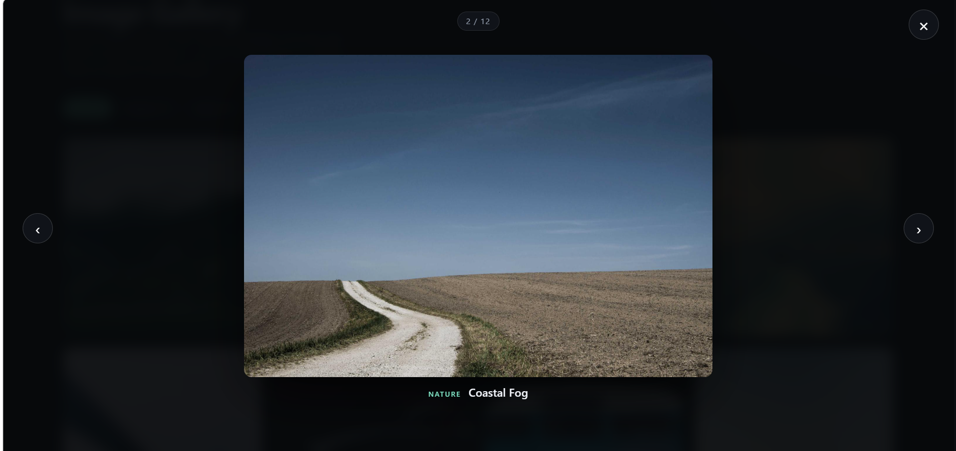

Figure 3. Gallery displayed at a mobile or narrow screen width


